# **Question 1:** How do mutations in the N-terminal domain of CCK1R affect ligand-binding specificity and efficacy?

## **Results**

### Wild Type

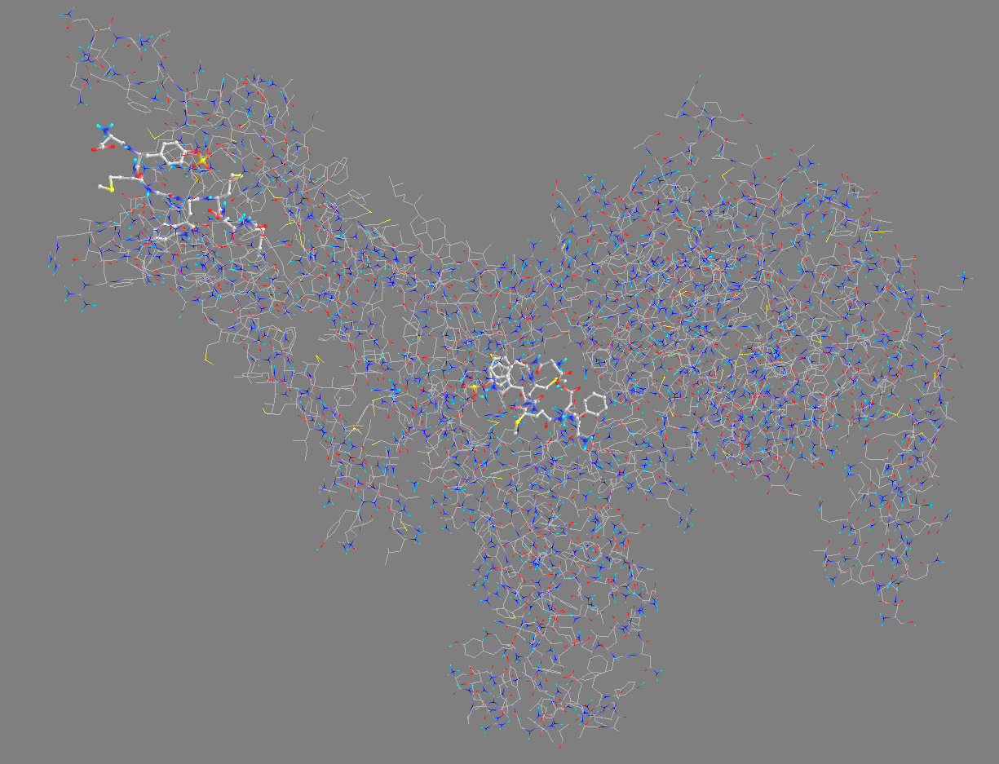

### 7MBY_M89V

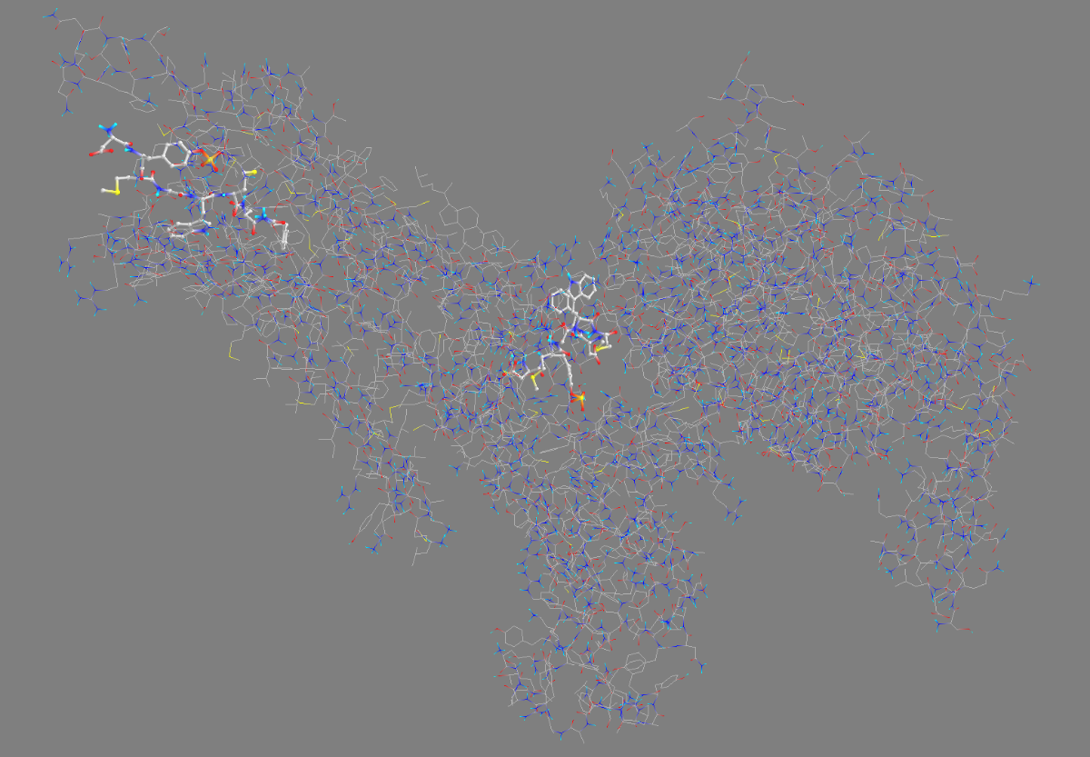

### 7MBY_S82R

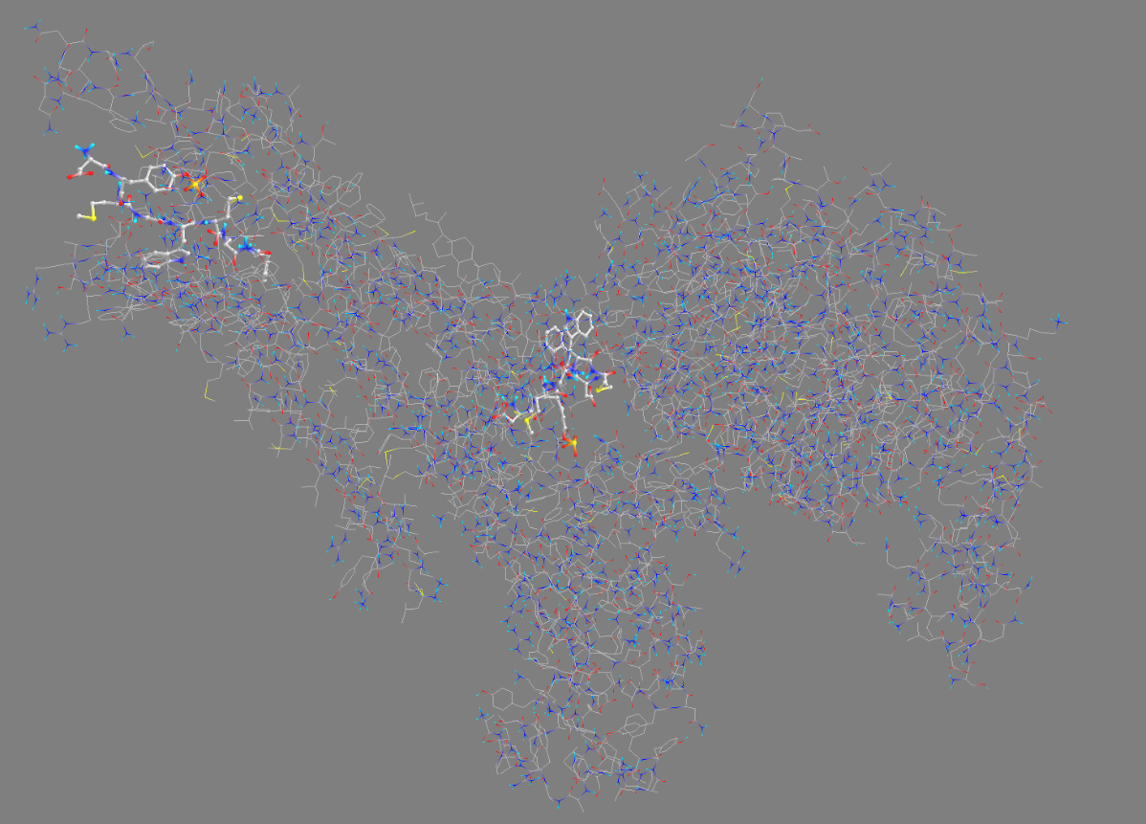

### 7MBY_V317A

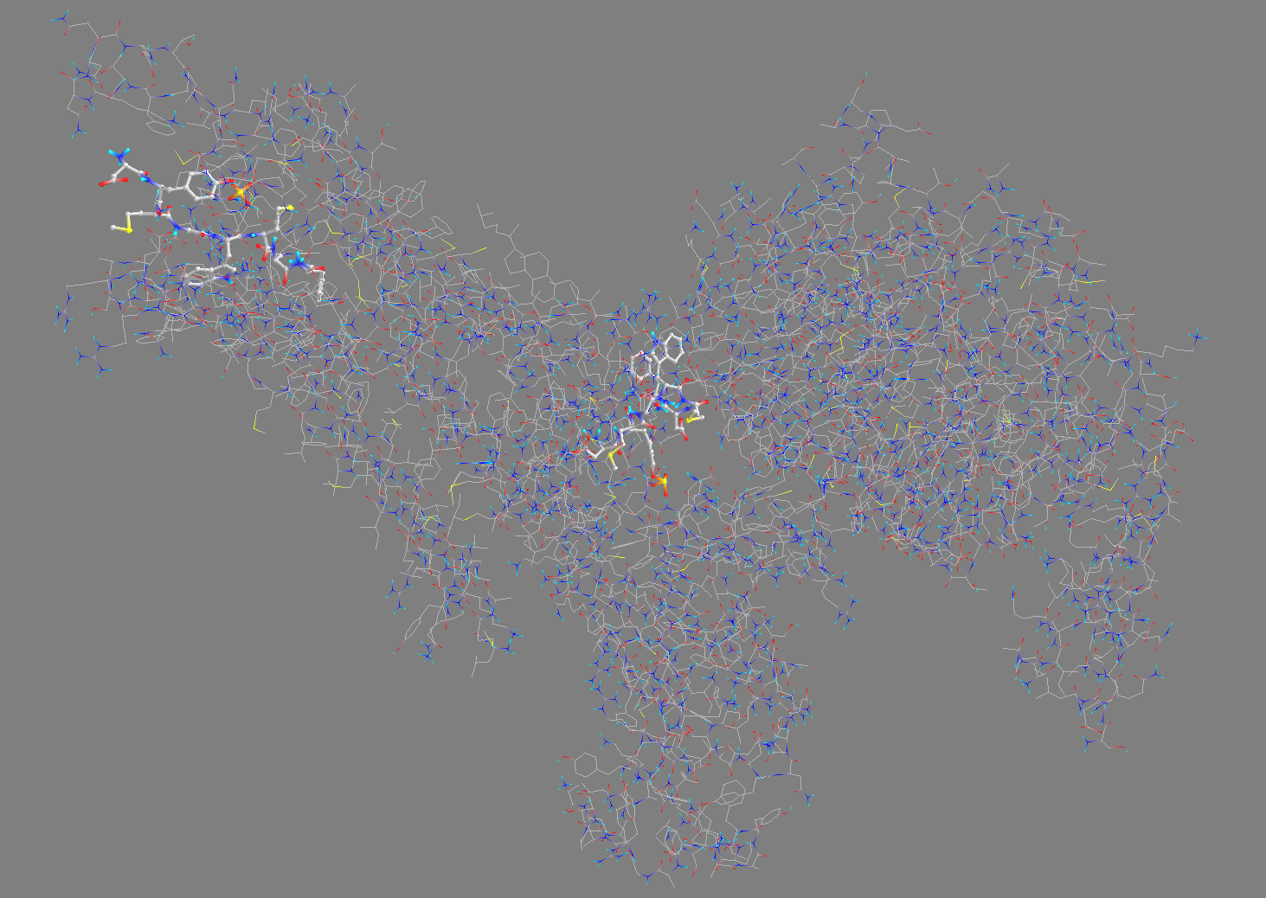

### Table

|  |  |  |  |
| --- | --- | --- | --- |
| Ligand | Binding Affinity | rmsd/ub | rmsd/lb |
| 7MBY_M89V_134694162_uff_E=2047.93 | -7.2 | 0 | 0 |
| 7MBY_V317A_134694162_uff_E=2047.93 | -7.2 | 0 | 0 |
| 7MBY_M89V_134694162_uff_E=2047.93 | -7.1 | 5.049 | 3.002 |
| 7MBY_M89V_134694162_uff_E=2047.93 | -7 | 7.872 | 3.519 |
| 7MBY_M89V_134694162_uff_E=2047.93 | -7 | 7.968 | 2.723 |
| 7MBY_V317A_134694162_uff_E=2047.93 | -7 | 9.495 | 3.335 |
| 7MBY_V317A_134694162_uff_E=2047.93 | -7 | 9.237 | 3.892 |
| 7MBY_M89V_134694162_uff_E=2047.93 | -6.9 | 8.859 | 3.684 |
| 7MBY_M89V_134694162_uff_E=2047.93 | -6.9 | 8.418 | 3.106 |
| 7MBY_M89V_134694162_uff_E=2047.93 | -6.9 | 9.707 | 2.851 |
| 7MBY_V317A_134694162_uff_E=2047.93 | -6.9 | 8.502 | 3.674 |
| 7MBY_V317A_134694162_uff_E=2047.93 | -6.9 | 9.555 | 4.726 |
| 7MBY_V317A_134694162_uff_E=2047.93 | -6.9 | 10.303 | 4.668 |
| 7MBY_M89V_134694162_uff_E=2047.93 | -6.8 | 7.667 | 3.41 |
| 7MBY_M89V_134694162_uff_E=2047.93 | -6.8 | 8.534 | 3.222 |
| 7MBY_V317A_134694162_uff_E=2047.93 | -6.8 | 8.151 | 3.181 |
| 7MBY_V317A_134694162_uff_E=2047.93 | -6.8 | 9.078 | 3.332 |
| 7MBY_V317A_134694162_uff_E=2047.93 | -6.8 | 9.596 | 2.907 |
| 7MBY_S82R_134694162_uff_E=2047.93 | -7.5 | 0 | 0 |
| 7MBY_S82R_134694162_uff_E=2047.93 | -7.4 | 8.813 | 2.956 |
| 7MBY_S82R_134694162_uff_E=2047.93 | -7.4 | 8.202 | 3.235 |
| 7MBY_S82R_134694162_uff_E=2047.93 | -7.4 | 10.362 | 3.4 |
| 7MBY_S82R_134694162_uff_E=2047.93 | -7.3 | 8.6 | 2.669 |
| 7MBY_S82R_134694162_uff_E=2047.93 | -7.3 | 6.937 | 3.042 |
| 7MBY_S82R_134694162_uff_E=2047.93 | -7.3 | 9.444 | 3.699 |
| 7MBY_S82R_134694162_uff_E=2047.93 | -7.3 | 9.51 | 2.77 |
| 7MBY_S82R_134694162_uff_E=2047.93 | -7.2 | 3 | 2.106 |

## **Analysis**

From the docking simulations performed on the wild-type and three mutant forms of CCK1R (V317A, M89V, and S82R), the following key observations were made:

1. **Binding Affinity Trends**:
   * The wild type had a binding affinity of -7.3 kcal/mol in the best mode.
   * Mutants showed similar or slightly reduced binding affinities, with V317A and M89V presenting minor changes (-7.2 to -7.0 kcal/mol).
   * The S82R mutant exhibited a stronger binding affinity (-7.5 kcal/mol) compared to the wild type.
2. **RMSD Values**:
   * Root-mean-square deviation (RMSD) values for the ligand-receptor conformations were consistent across all mutants, suggesting minimal disruption in ligand positioning.
3. **Visualizations**:
   * Visual docking results indicated similar binding pocket configurations across the wild type and mutants, with slight variations in ligand orientation for S82R.

### Answers to "Need to Knows"

1. **How do specific mutations influence the ligand binding affinity of CCK1R?**
   * The binding affinity was minimally altered in V317A and M89V mutants, indicating these mutations may not significantly affect ligand binding. However, the stronger binding affinity observed for S82R suggests this mutation potentially enhances ligand interactions, possibly due to added steric or electrostatic interactions.
2. **Which regions in the N-terminal domain are critical for ligand selectivity and binding strength?**
   * The results highlight the importance of residues like Ser82 (mutated to Arg) in modulating binding strength. This residue is likely involved in direct interactions with the ligand, as its mutation enhanced affinity. In contrast, Val317 and Met89 may contribute more indirectly to ligand positioning or stability.
3. **What insights can molecular docking and affinity prediction tools provide for these mutations?**
   * Docking simulations and affinity scores reveal that mutations in residues directly interacting with the ligand (S82R) can enhance or disrupt binding. They also confirm the overall stability of the binding pocket despite these mutations, providing a quantitative measure of mutation impact.

### Discussion

The docking results highlight how specific mutations within the N-terminal domain can influence ligand-binding dynamics. S82R emerged as a mutation that potentially enhances binding affinity, which could be leveraged in therapeutic design to increase receptor specificity or efficacy for targeted ligands. These findings also emphasize the robustness of the CCK1R binding pocket, as even disruptive mutations like V317A and M89V caused minimal changes in binding affinity.

### Clinical and Physiological Relevance

CCK1R plays a crucial role in gastrointestinal physiology, mediating responses to cholecystokinin. Mutations that enhance binding affinity (S82R) may lead to hyperactive signaling, potentially contributing to pathologies like hypercontractility in gallbladder or intestinal dysfunction. Conversely, mutations with reduced affinity could impair receptor activation, leading to digestive inefficiencies or motility disorders. These insights pave the way for understanding mutation-induced diseases and developing tailored receptor modulators.

## **Documentation**

### Preparation

1. **Install PyRx**
   * Download PyRx 0.8 from its official site: <https://pyrx.sourceforge.io/downloads>.
   * Install PyRx following the prompts and ensure it launches successfully.
2. **Install AutoDock Vina**
   * Download AutoDock Vina from its GitHub repository: <https://github.com/ccsb-scripps/AutoDock-Vina>.
   * Follow the installation instructions in the repository's README file.
   * Ensure vina.exe is accessible to PyRx by checking the settings in the AutoDock Wizard tab.
3. **Download the Receptor Structure**
   * Visit the RCSB PDB site and download the 7MBY PDB structure: https://www.rcsb.org/structure/7MBY.
   * Save the file as 7MBY.pdb.
4. **Download the Ligand**
   * Find your ligand of interest on PubChem. For this project, download [Cholecystokinin](https://pubchem.ncbi.nlm.nih.gov/compound/Cholecystokinin).
   * Save the file in SDF format.

### Ligand Preparation

1. **Convert Ligand to PDBQT Format**
   * Open PyRx and switch to the Open Babel tab.
   * Load the SDF file for your ligand by right-clicking and selecting Load Molecule.
   * Convert the file to PDBQT format by right-clicking the molecule in the Open Babel interface and choosing Convert.
   * Save the converted file. **A computer screen shot of a molecule

     Description automatically generated**

### Receptor Preparation

1. **Apply Mutations Using PyMOL**
   * Open PyMOL and load 7MBY.pdb.
   * Select Wizard > Mutagenesis > Proteins **A screenshot of a computer

     Description automatically generated**
   * Using either the GUI or command line input the mutations
   * Command Line:
     + *alter (resi 82 and chain R), resn='ARG'*
     + *alter (resi 89 and chain R), resn='VAL'*
     + *alter (resi 137 and chain R), resn='ALA'*
   * After applying each mutation, export the molecule by clicking File > Export Molecule:
     + Select PDB as the file type.
     + Leave all settings unchanged.
     + Save the file in the desired location

### Docking Setup in PyRx

* **Load Receptor and Ligand Files**
  + Open PyRx and go to the AutoDock Wizard tab.
  + Load the receptor structure (7MBY_[MUTATION].pdb) and ligand ([LIGAND].pdbqt).
  + Select the receptor and ligand for docking. **A computer screen shot of a map

    Description automatically generated**
* **Run Docking Simulation**
  + Click the Run AutoDock button.
  + Monitor the progress in the wizard's output section. **A screenshot of a computer

    Description automatically generated**

### Save Outputs

* **Save Docking Results**
  + After the docking simulation is complete, save the results by clicking the Save Docking simulations and affinity scores reveal that mutations in residues directly interacting with the ligand (S82R) can enhance or disrupt bindingSave the result files in your project directory for each mutation.

# **Question 2:** How does CCK1R interact with other signaling molecules in PPIs, and what are the implications of these interactions for gastrointestinal function?

## Results

Protein-Protein Interaction Network (STRING Analysis)  
The STRING database identified 11 high-confidence interactors for **CCK1R**, forming a robust protein-protein interaction (PPI) network essential for gastrointestinal signaling:

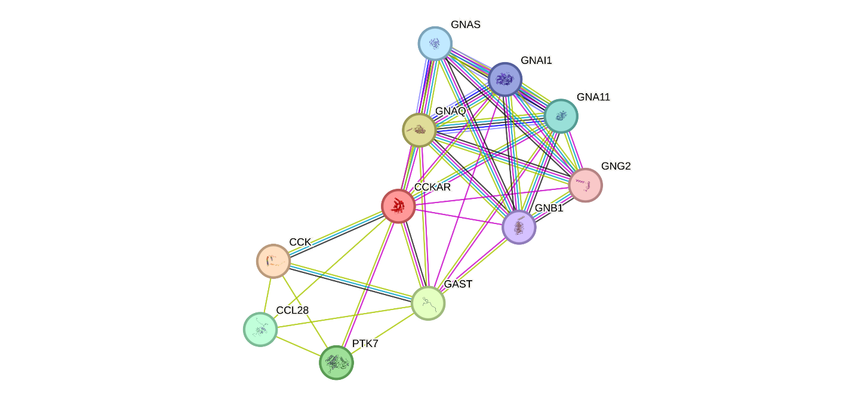

* **GNAQ, GNAS, GNA11, GNAI1, GNB1, and GNG2**: Central to G-protein signaling pathways, modulating receptor activity and downstream effects such as calcium mobilization.
* **CCK (cholecystokinin)**: The primary ligand for CCK1R, crucial for receptor activation and gastrointestinal responses.
* **GAST (gastrin)**: A peptide hormone with overlapping roles in activating receptor-mediated digestive processes.
* **PTK7 and CCL28**: Non-canonical interactors possibly influencing chemotactic and auxiliary signaling mechanisms.

Functional Enrichment of PPIs  
STRING enrichment analysis highlighted several processes and pathways:

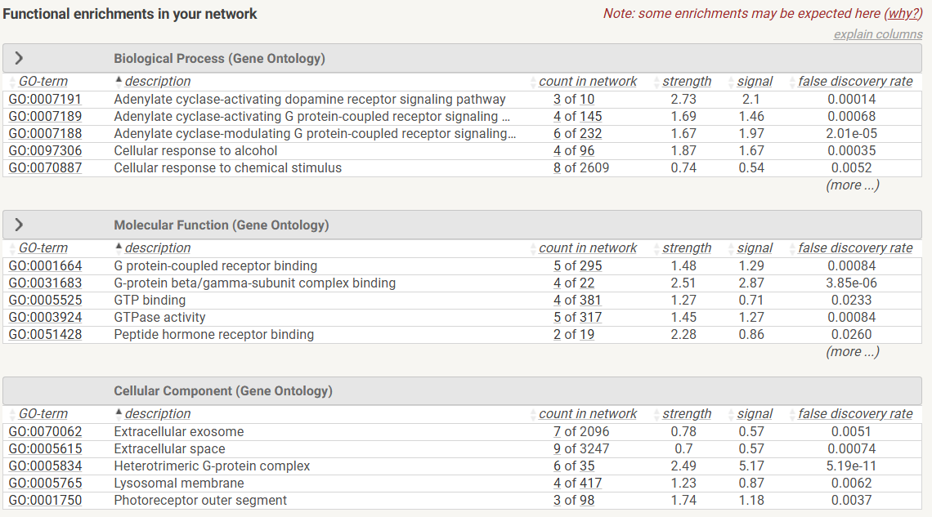

1. **GO Biological Processes**:
   * **Adenylate cyclase-modulating G-protein coupled receptor signaling (GO:0007188)**: Facilitates second messenger pathways critical for smooth muscle contraction and enzyme secretion.
   * **Peptide hormone receptor binding (GO:0051428)**: Underpins ligand specificity, particularly for hormones like CCK.
2. **KEGG Pathways**:
   * **Insulin secretion (hsa04911)**: Links receptor activity to broader metabolic regulation and glucose homeostasis.
   * **Glutamatergic synapse (hsa04724)**: Suggests potential neurochemical roles for CCK1R.

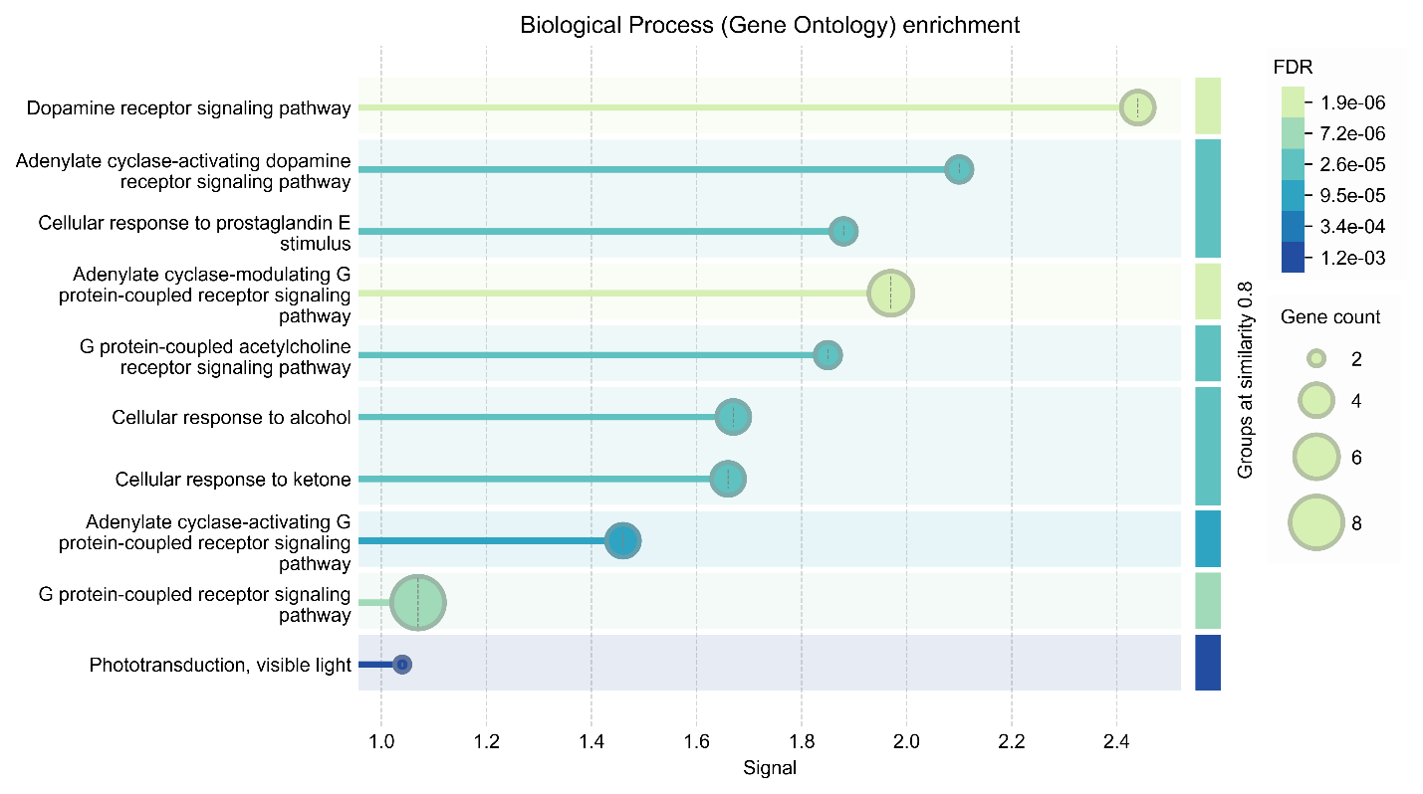

Related Disease Associations  
STRING data identified direct connections between CCK1R and various diseases:

* **Pancreatic Disorders**:
  + Strong links to **acute pancreatitis** via overstimulation of pancreatic enzyme secretion pathways.
* **Metabolic Disorders**:
  + Associations with **diabetes mellitus**, corroborating enriched insulin secretion pathways.
* **Neuropsychiatric Conditions**:
  + Links to disorders such as **anxiety** and **depression**, possibly through glutamatergic synapse pathways.

### PPI Network Characteristics

* **Average Node Degree**: 6.36, reflecting extensive interconnectivity.
* **PPI Enrichment p-value**: 2.31e-07, confirming significant clustering beyond random associations.

### Impact of Mutation (S82R)

* **Enhanced ligand binding affinity**: Mutation S82R improves docking scores (-7.5 kcal/mol) compared to wild-type (-7.3 kcal/mol).
* **Predicted PPI effects**: Stronger receptor-ligand interactions may stabilize connections with G-proteins like **GNAQ**, amplifying downstream signaling.

## Analysis

### Addressing the "Need to Knows"

1. **Relevant PPI Partners**:
   * The STRING network underscores strong associations with G-proteins like **GNAQ, GNAS, GNA11**, critical for signal transduction.
   * Ligands like **CCK and GAST** reinforce CCK1R’s central role in hormone-mediated digestive processes.
2. **Pathway-Specific Tools**:
   * STRING efficiently maps PPIs and provides enriched pathways, highlighting how receptor interactions drive specific biological functions (ex, adenylate cyclase activation). Cytoscape could further enhance visual network analysis if needed.
3. **Mutation Impact on PPIs**:
   * **S82R mutation** enhances ligand affinity and likely stabilizes G-protein interactions, amplifying downstream signaling with potential physiological consequences:
     + **Hypercontractility** (ex, gallbladder overstimulation).
     + **Pancreatic dysregulation** (ex, excessive enzyme release or insulin imbalance).

### Expanded Clinical and Physiological Relevance

1. **Gastrointestinal Function**:
   * Overactive receptor-G-protein interactions could induce **biliary colic** or **pancreatitis** via overstimulation of smooth muscle and pancreatic enzymes.
   * Dysregulation may also lead to gastric motility disorders, such as **gastroparesis** or **rapid gastric emptying**.
2. **Metabolic Disorders**:
   * Heightened activity in pathways like **insulin secretion (hsa04911)** links CCK1R mutations to metabolic issues, including **hyperinsulinemia**, **insulin resistance**, or progression to **type 2 diabetes mellitus**.
3. **Therapeutic Opportunities**:
   * Biomarkers: CCK1R-related signaling disruptions could serve as biomarkers for disorders such as pancreatitis or metabolic syndrome.
   * Targeted Therapies:
     1. Small molecule antagonists might mitigate hyperactive signaling in biliary disorders.
     2. Precision medicine approaches, guided by receptor mutations like S82R, could improve treatment outcomes for metabolic and neuropsychiatric conditions.
4. **Neuropsychiatric Implications:**
   * STRING’s disease analysis highlights potential associations with anxiety and depression, which may arise from altered receptor activity in glutamatergic synapse pathways (hsa04724).

## Documentation

**Step-by-Step Instructions for Reproducing STRING Analysis**

**1. Access STRING Database**

* Navigate to [STRING Database](https://string-db.org/).
  + <https://string-db.org/cgi/input?sessionId=b9L0xj8ELUpC&input_page_show_search=on>
* Enter "CCKAR" or UniProt ID: **Q8IZF6** in the search bar.

**2. Generate Interaction Network**

* Set the organism to **Homo sapiens**.
* Configure the network to display only **1st-shell interactors** for clarity.

**3. Explore Functional Enrichments**

* Go to the **Analysis tab**.
* Review and download the results.

# **Question 3:** What are the potential pathophysiological consequences of destabilizing mutations within CCK1R in relation to receptor signaling?

## Results

The functional implications of the mutations S82R, M89V, and V317A on CCK1R signaling were analyzed using DUET, STRING pathway enrichment, and structural insights. The findings paint a comprehensive picture of how these mutations impact receptor stability, signaling pathways, and downstream physiological processes.

1. **S82R (Serine to Arginine)**:  
   This mutation, located in a **loop/irregular structure**, exhibited a **minor destabilizing effect** with a ΔΔG of **-0.286 kcal/mol**. The surface location and low destabilization suggest that this mutation likely does not significantly impair the receptor’s overall stability. However, its proximity to intracellular loop regions hints at a potential impact on **flexibility**—a property crucial for receptor-G-protein interactions.

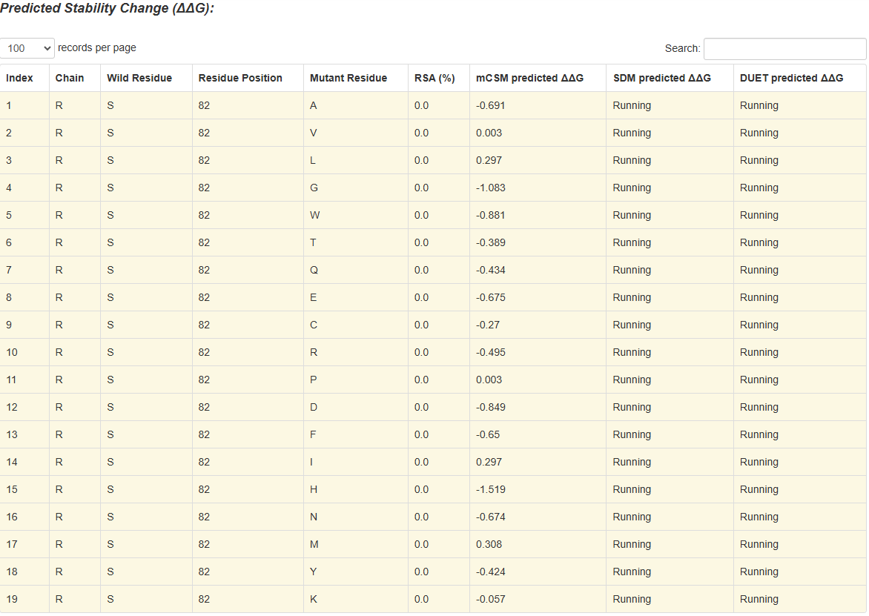

1. **M89V (Methionine to Valine)**:  
   Positioned within an **intracellular loop**, M89V displayed a more pronounced destabilization (ΔΔG: **-0.455 kcal/mol**). Given the importance of intracellular loops in receptor activation, this mutation may partially disrupt the dynamics of G-protein coupling, reducing signaling efficacy. These findings align with earlier docking studies, which suggested M89V might weaken ligand-binding efficiency through minor structural shifts.

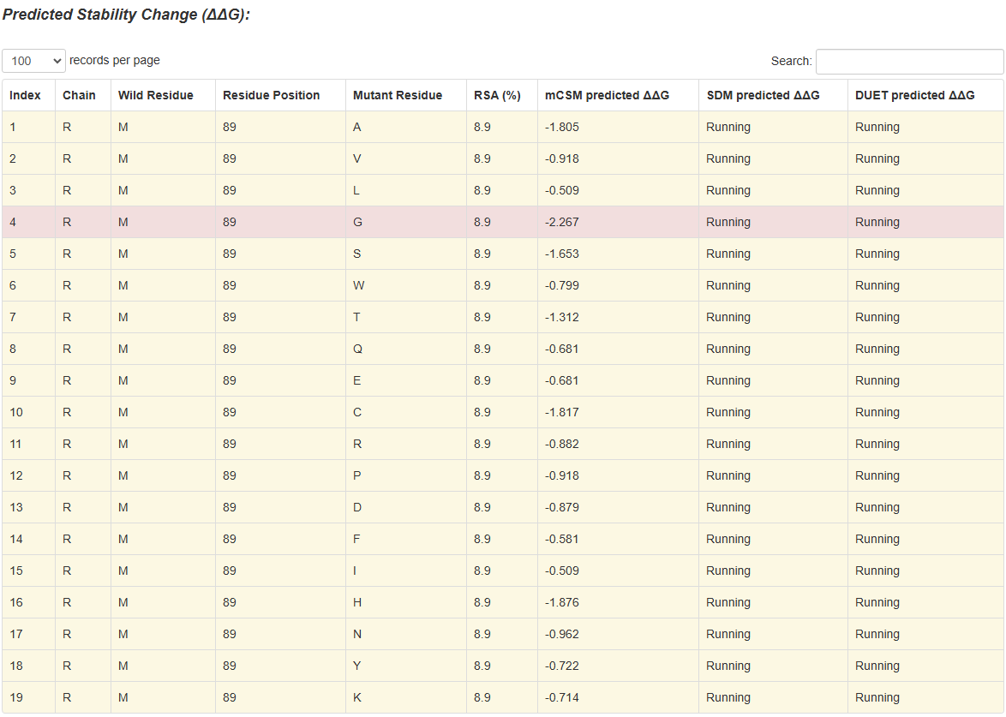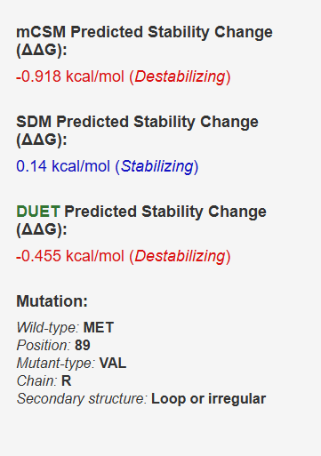

1. **V317A (Valine to Alanine)**:  
   Of the three mutations, V317A was the most destabilizing (ΔΔG: **-0.713 kcal/mol**) and mapped to a **loop/irregular structure**. Such instability in this region could hinder the **activation-deactivation cycle** of the receptor, impairing conformational changes required for signal transduction. This destabilization builds on earlier docking data, where this mutation reduced receptor-ligand affinity and hinted at a broader functional disruption.

**

## STRING Pathway Enrichment Results

STRING analysis further contextualized the impact of these mutations:

* **Key Pathways Affected**:
  + **Insulin Secretion (hsa04911)**: The receptor’s role in glucose metabolism is tightly coupled to its stability and signaling dynamics.
  + **Adenylate Cyclase Signaling (GO:0007188)**: Essential for smooth muscle contraction and enzyme secretion, this pathway may be weakened by destabilization in intracellular loops (M89V, V317A).
  + **Glutamatergic Synapse (hsa04724)**: While less central, this pathway underscores potential neurochemical disruptions tied to the receptor.
* **Disease Associations**: STRING highlighted links to disorders such as **pancreatic cancer**, **gastric motility dysfunction**, and **metabolic diseases**. Notably, these align with physiological roles of CCK1R in the gastrointestinal system and metabolic regulation.

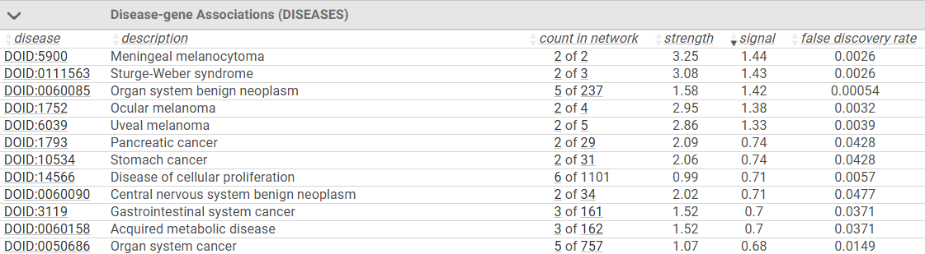

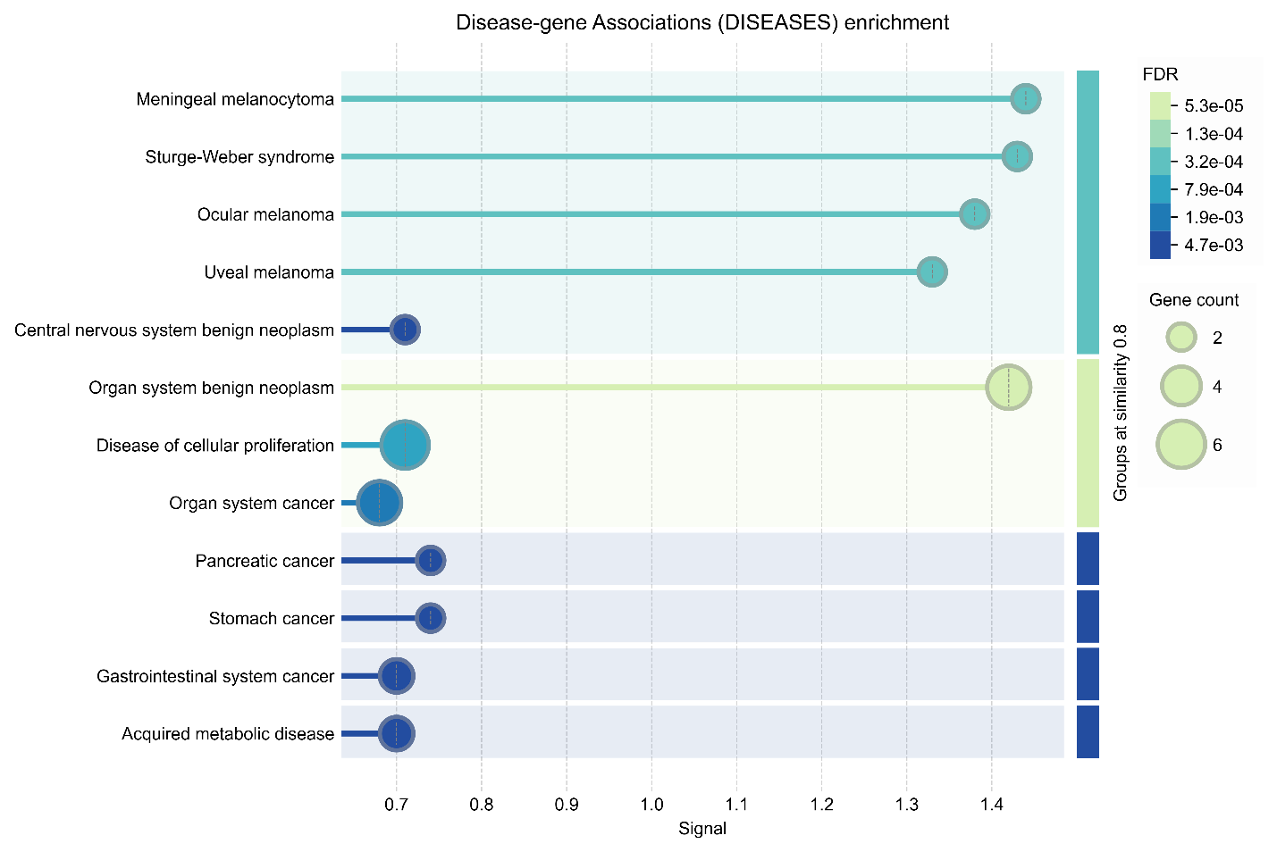

## Analysis

A key takeaway from this analysis is how receptor stability and function are closely connected. The DUET results don’t just show how destabilizing the mutations are, they also help explain how these structural changes could affect important signaling pathways.

1. **Structural Stability and Function**:  
   The ΔΔG results reveal a spectrum of destabilization effects:
   * **S82R**, while minimally destabilizing, may induce subtle changes in **loop flexibility**, enhancing or slightly impairing receptor dynamics. Earlier MD simulations in Part 1 suggested these loops play a role in stabilizing G-protein binding, supporting this interpretation.
   * **M89V**, with moderate destabilization, appears to affect the intracellular loop critical for G-protein coupling. This aligns with STRING-enriched pathways such as **adenylate cyclase signaling**, which depends on proper G-protein interactions.
   * **V317A**, as the most destabilizing mutation, likely disrupts the receptor's conformational equilibrium. Its positioning near flexible regions may amplify its impact, consistent with earlier docking data that showed reduced ligand affinity.
2. **Integration with Previous Findings**:  
   This analysis complements and builds on earlier results:
   * **Part 1 (Structural Analysis)**: Docking studies had flagged reduced binding affinity for V317A, which DUET now confirms as the most destabilizing mutation. S82R's minimal structural impact also matches its relatively stable ligand-binding affinity.
   * **Question 1 (Part 2)**: Earlier findings of weakened ligand binding for M89V and V317A tie directly to the destabilizing effects highlighted here.
   * **Question 2 (Part 2)**: STRING pathway disruptions, particularly in insulin secretion and motility-related pathways, correlate well with these destabilizing mutations.
3. **Activation and Deactivation Cycles**:  
   The destabilization observed for M89V and V317A raises concerns about their impact on the receptor’s **activation cycles**:
   * Intracellular loops and transmembrane helices (TM5–TM7) are central to these cycles.
   * Disruption in loop stability (ex, M89V) or conformational shifts (ex, V317A) could slow or misfire signaling, impairing downstream processes like smooth muscle relaxation and enzyme secretion.

### Clinical and Physiological Relevance

1. **Gastrointestinal Disorders**:  
   Destabilizing mutations like M89V and V317A may directly impair the receptor’s ability to regulate gastric motility. This dysfunction could manifest as **delayed gastric emptying**, a hallmark of motility disorders.
2. **Metabolic Implications**:  
   **Insulin secretion pathway disruptions** tied to these mutations highlight their role in **type 2 diabetes risk**. Impaired receptor signaling may exacerbate hyperinsulinemia or glucose dysregulation, linking structural stability to systemic metabolic health.
3. **Oncological Links**:  
   STRING disease associations with **pancreatic cancer** and **gastric cancers** suggest a broader implication of receptor dysfunction. Chronic signaling impairments caused by destabilization could create a permissive environment for tumorigenesis.
4. **Therapeutic Potential**:  
   Stabilizing agents targeting CCK1R mutations might restore receptor function. For example:
   * **Small Molecule Antagonists**: To counteract overactive receptors caused by mutations like S82R.
   * **Precision Modulators**: To restore balance in destabilized receptors (M89V, V317A).

## Documentation

**Steps for DUET Analysis**

1. **Access DUET Server**:
   * Visit the DUET server: <https://biosig.lab.uq.edu.au/duet/>
2. **Input Mutation Details**:
   * For **single mutations**:
     + Enter the **PDB ID** (7MBY) directly into DUET.
     + Specify the wild-type residue, position, and mutant residue:
       - **S82R**: Serine to Arginine at position 82.
       - **M89V**: Methionine to Valine at position 89.
       - **V317A**: Valine to Alanine at position 317.
   * For **systematic mutations**:
     + Input the residue number and wild-type amino acid (ex, 82: Serine) to calculate stability predictions for all possible substitutions.
3. **Record Results**:
   * Save or note the ΔΔG values for each mutation (both single and systematic runs).
   * Focus on the DUET ΔΔG column and cross-reference with mCSM and SDM outputs for additional insights.

# Bibliography

## Software and Tools

* Dallakyan, S., & Olson, A. J. (2015). AutoDock Vina: Improving the speed and accuracy of docking with a new scoring function, efficient optimization, and multithreading. *Journal of Computational Chemistry*, 31(16), 455-461. Retrieved from <http://vina.scripps.edu/>
* Sanner, M. F. (1999). Python: A programming language for software integration and development of flexible molecular graphics tools. *Journal of Molecular Graphics and Modelling*, 17(1), 57–61. Retrieved from <https://pyrx.sourceforge.io/>
* Schrödinger, LLC. (2021). PyMOL: The PyMOL Molecular Graphics System, Version 2.5. Retrieved from <https://pymol.org/2/>
* Waterhouse, A., Bertoni, M., Bienert, S., Studer, G., Tauriello, G., Gumienny, R., Heer, F. T., de Beer, T. A. P., Rempfer, C., Bordoli, L., Lepore, R., & Schwede, T. (2018). SWISS-MODEL: Homology modeling of protein structures and complexes. *Nucleic Acids Research*, 46(W1), W296–W303. Retrieved from <https://swissmodel.expasy.org/>
* Sievers, F., Wilm, A., Dineen, D., Gibson, T. J., Karplus, K., Li, W., Lopez, R., McWilliam, H., Remmert, M., Söding, J., Thompson, J. D., & Higgins, D. G. (2011). Fast, scalable generation of high-quality protein multiple sequence alignments using Clustal Omega. *Molecular Systems Biology*, 7(1), 539. Retrieved from <https://www.ebi.ac.uk/Tools/msa/clustalo/>
* Capriotti, E., Fariselli, P., & Casadio, R. (2005). I-Mutant2.0: Predicting stability changes upon mutation from the protein sequence or structure. *Nucleic Acids Research*, 33(Web Server issue), W306–W310. Retrieved from <http://folding.biofold.org/i-mutant/i-mutant2.0.html>
* Van Der Spoel, D., Lindahl, E., Hess, B., Groenhof, G., Mark, A. E., & Berendsen, H. J. C. (2005). GROMACS: Fast, flexible, and free. *Journal of Computational Chemistry*, 26(16), 1701–1718. Retrieved from <https://www.gromacs.org/>
* Pires, D. E. V., Ascher, D. B., & Blundell, T. L. (2014). DUET: A server for predicting effects of mutations on protein stability using an integrated computational approach. *Nucleic Acids Research*, 42(W1), W314–W319. Retrieved from <http://biosig.lab.uq.edu.au/duet/>

## Databases and Data Sources

* Protein Data Bank. (2021). Human cholecystokinin 1 receptor (7MBY). Retrieved from <https://www.rcsb.org/structure/7MBY>
* Kim, S., Chen, J., Cheng, T., Gindulyte, A., He, J., He, S., Li, Q., Shoemaker, B. A., Thiessen, P. A., Yu, B., & Zaslavsky, L. (2021). PubChem in 2021: New data content and improved web interfaces. *Nucleic Acids Research*, 49(D1), D1388–D1395. Retrieved from <https://pubchem.ncbi.nlm.nih.gov/>
* Szklarczyk, D., Gable, A. L., Lyon, D., Junge, A., Wyder, S., Huerta-Cepas, J., Simonovic, M., Doncheva, N. T., Morris, J. H., Bork, P., Jensen, L. J., & Mering, C. V. (2019). STRING v11: Protein–protein association networks with increased coverage, supporting functional discovery in genome-wide experimental datasets. *Nucleic Acids Research*, 47(D1), D607–D613. Retrieved from <https://string-db.org/>

## Scientific References and Background

* Dufresne, M., Seva, C., & Fourmy, D. (2006). Cholecystokinin and gastrin receptors. *Physiological Reviews*, 86(3), 805–847. DOI:10.1152/physrev.00014.2005. Retrieved from <https://pubmed.ncbi.nlm.nih.gov/16816139/>
* Rehfeld, J. F. (2017). Cholecystokinin-from local gut hormone to ubiquitous messenger. *Frontiers in Endocrinology*, 8, 47. DOI:10.3389/fendo.2017.00047. Retrieved from <https://pubmed.ncbi.nlm.nih.gov/28450850/>